AxExtend DLL
Overview
AxExtend is a .NET library (DLL) designed to provide a set of extension services for building custom API Pluings. It abstracts and simplifies common operations such as database access, Redis caching, and RabbitMQ and session access and other integration points, allowing developers to focus on business logic rather than infrastructure code.

Key Features
- Database Operations: Simplified methods for opening connections, executing SQL queries, and managing transactions.
- Redis Caching: Easy-to-use methods for connecting to Redis, performing cache operations, and managing cache lifecycle.
- Extensible Interfaces: All core services are exposed via interfaces, making it easy to swap implementations or mock for testing.
- Async Support: All I/O operations are asynchronous, supporting modern scalable .NET applications.

Getting Started
1. Add Reference
Add the AxExtend.dll and ARMCommon.DLL to your project:
- Right-click your project in Visual Studio.
- Select Add > COM Reference...
- Browse to the location of AxExtend.dll and ARMCommon.DLL and add it.

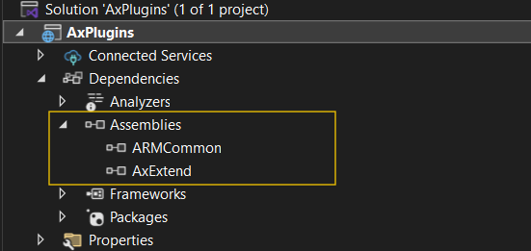

2. Register Services
Register the required services in your Startup.cs or Program.cs (for .NET 8):

services.AddScoped<IAxExtend, AxExtend>();

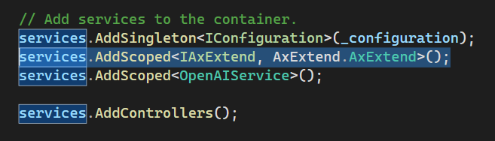

3) IAxExtend Interface – Detailed Explanation
The IAxExtend interface is the main contract for the AxExtend library, designed to provide a unified set of extension services for .NET applications. It abstracts common infrastructure operations such as database access, Redis caching, session management, and RabbitMQ messaging, making it easier to build scalable and maintainable applications.

Method Details
- GetDBConfigurations(string appName)
Retrieves database configuration settings for the specified application.
- OpenDBConnectionAsync(string appName)
Opens a database connection for the given application.
- GetDB()
Returns an DB Object instance for executing database operations.
- CloseDBConnectionAsync()
Closes the current database connection.
- OpenRedisConnectionAsync(string cacheKey = "")
Opens a Redis cache connection, optionally using a specific cache key.
- GetRedis()
Returns an RedisObject instance for Redis operations.
- CloseRedisConnectionAsync()
Closes the current Redis connection.
- ValidateSession(string sessionId)
Validates if a session is active and valid.
- GetSessionData(string sessionId)
Retrieves session data as a dictionary for the given session ID.
- GetRabbitMQProducer()
Returns an RabbitMQProducer object for publishing messages to RabbitMQ.
- GetRabbitMQConsumer()
Returns an RabbitMQConsumer object for consuming messages from RabbitMQ.
- GetAppSettings()
Returns an appsettings object to read data from appsettings.ini file for accessing application settings.

Published AxExtend folder:
